LED Greeting Card
Description:
A creative project where LEDs are embedded inside a greeting card to make designs or highlight messages. When the card is opened, a switch activates and lights up the LEDs. It combines creativity with basic electronics, making it a fun project for students interested in both art and engineering.
Block Diagram:
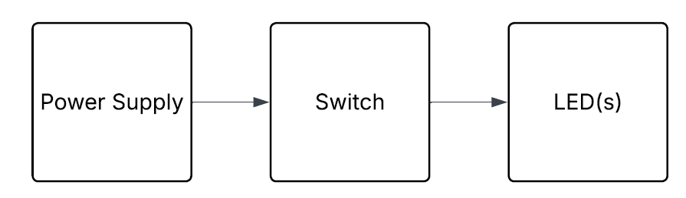
Pinout / Circuit Connection:
- Coin cell battery → LED
- Micro switch → card open/close
- Parallel connections for multiple LEDs
Components Required:
- LEDs
- Coin cell battery (CR2032)
- Micro switch
- Greeting card material
- Decorative items
Working Principle:
The card uses a simple open-close mechanism. When the greeting card is opened, the micro switch closes the circuit, turning ON the LEDs. When the card is closed, the circuit breaks and LEDs turn OFF. This project introduces the idea of practical switches in everyday objects.
Operation (Step-by-Step):
- Prepare greeting card design.
- Embed LEDs and battery inside.
- Add micro switch in hinge area.
- Open card → LEDs light up.
Conclusion:
The LED Greeting Card project blends art and electronics, showing how simple circuits can be integrated into creative items. It encourages innovation in design and serves as a great demonstration of real-world applications of basic electronics.
References:
[1] S. Monk, “Make: Electronics Projects,” Maker Media, 2015.
[2] Electronics Tutorials, “Switches in Circuits,” 2020. [Online]. Available: https://www.electronics-tutorials.ws/switches/. [Accessed: Sep. 13, 2025].

